|  |
| --- |
|  |
| Screen Specification |
| Register to Borrow Use Case |
|  |
| **Chu Quoc Hung** |
| **10-Mar-17** |

Screen Specification for Register to Borrow Use Case.

Table of Contents

1. Pages 3

1.1. Page Tree 3

1.2. Home 4

1.2.1. User Interface 4

1.2.2. Widget Table 4

1.3. Register to Borrow Popup 8

1.3.1. User Interface 8

1.3.2. Widget Table 8

1.4. Account Settings 10

1.4.1. User Interface 10

1. Pages
   1. Page Tree

Home  
 Register to Borrow Popup  
Account Settings

* 1. Home
     1. User Interface

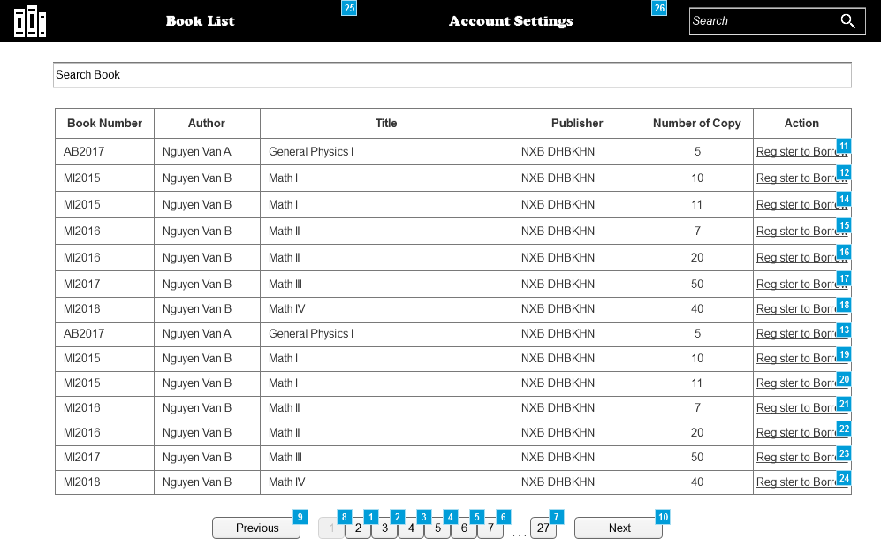

* + 1. Widget Table

|  |  |  |
| --- | --- | --- |
| Footnote | Name | Interactions |
| 1 | 2 | OnClick:  Case 1:  Show/Hide Widget  Show/Hide Widget  Enable 1, 3, 4, 6, 5, 7, 27  Disable 2 |
| 2 | 3 | OnClick:  Case 1:  Show/Hide Widget  Show/Hide Widget  Enable 1, 2, 4, 5, 6, 27, 7  Disable 3 |
| 3 | 4 | OnClick:  Case 1:  Show/Hide Widget  Show/Hide Widget  Enable 1, 2, 5, 6, 27, 7, 3  Disable 4 |
| 4 | 5 | OnClick:  Case 1:  Show/Hide Widget  Show/Hide Widget  Enable 1, 2, 4, 6, 27, 7, 3  Disable 5 |
| 5 | 6 | OnClick:  Case 1:  Show/Hide Widget  Show/Hide Widget  Enable 1, 2, 4, 5, 27, 7, 3  Disable 6 |
| 6 | 7 | OnClick:  Case 1:  Show/Hide Widget  Show/Hide Widget  Enable 1, 2, 4, 5, 6, 27, 3  Disable 7 |
| 7 | 27 | OnClick:  Case 1:  Show/Hide Widget  Show/Hide Widget  Enable 1, 2, 4, 5, 6, 3, 7  Disable 27 |
| 8 | 1 | OnClick:  Case 1:  Show/Hide Widget  Show/Hide Widget  Enable 3, 2, 4, 5, 6, 27, 7  Disable 1 |
| 9 |  | OnClick:  Case 1:  Show/Hide Widget  Show/Hide Widget |
| 10 |  | OnClick:  Case 1:  Show/Hide Widget  Show/Hide Widget |
| 11 |  | OnClick:  Case 1:  Open Register to Borrow Popup in Popup Window  Set value of BookNumber equal to text on 1 row 1, and  value of Author equal to text on 2 row 1, and  value of Title equal to text on 3 row 1 |
| 12 |  | OnClick:  Case 1:  Open Register to Borrow Popup in Popup Window  Set value of BookNumber equal to text on 1 row 2, and  value of Author equal to text on 2 row 2, and  value of Title equal to text on 3 row 2 |
| 13 |  | OnClick:  Case 1:  Open Register to Borrow Popup in Popup Window  Set value of BookNumber equal to text on 1 row 1, and  value of Author equal to text on 2 row 1, and  value of Title equal to text on 3 row 1 |
| 14 |  | OnClick:  Case 1:  Open Register to Borrow Popup in Popup Window  Set value of BookNumber equal to text on 1 row 2, and  value of Author equal to text on 2 row 2, and  value of Title equal to text on 3 row 2 |
| 15 |  | OnClick:  Case 1:  Open Register to Borrow Popup in Popup Window  Set value of BookNumber equal to text on 1 row 2, and  value of Author equal to text on 2 row 2, and  value of Title equal to text on 3 row 2 |
| 16 |  | OnClick:  Case 1:  Open Register to Borrow Popup in Popup Window  Set value of BookNumber equal to text on 1 row 2, and  value of Author equal to text on 2 row 2, and  value of Title equal to text on 3 row 2 |
| 17 |  | OnClick:  Case 1:  Open Register to Borrow Popup in Popup Window  Set value of BookNumber equal to text on 1 row 2, and  value of Author equal to text on 2 row 2, and  value of Title equal to text on 3 row 2 |
| 18 |  | OnClick:  Case 1:  Open Register to Borrow Popup in Popup Window  Set value of BookNumber equal to text on 1 row 2, and  value of Author equal to text on 2 row 2, and  value of Title equal to text on 3 row 2 |
| 19 |  | OnClick:  Case 1:  Open Register to Borrow Popup in Popup Window  Set value of BookNumber equal to text on 1 row 2, and  value of Author equal to text on 2 row 2, and  value of Title equal to text on 3 row 2 |
| 20 |  | OnClick:  Case 1:  Open Register to Borrow Popup in Popup Window  Set value of BookNumber equal to text on 1 row 2, and  value of Author equal to text on 2 row 2, and  value of Title equal to text on 3 row 2 |
| 21 |  | OnClick:  Case 1:  Open Register to Borrow Popup in Popup Window  Set value of BookNumber equal to text on 1 row 2, and  value of Author equal to text on 2 row 2, and  value of Title equal to text on 3 row 2 |
| 22 |  | OnClick:  Case 1:  Open Register to Borrow Popup in Popup Window  Set value of BookNumber equal to text on 1 row 2, and  value of Author equal to text on 2 row 2, and  value of Title equal to text on 3 row 2 |
| 23 |  | OnClick:  Case 1:  Open Register to Borrow Popup in Popup Window  Set value of BookNumber equal to text on 1 row 2, and  value of Author equal to text on 2 row 2, and  value of Title equal to text on 3 row 2 |
| 24 |  | OnClick:  Case 1:  Open Register to Borrow Popup in Popup Window  Set value of BookNumber equal to text on 1 row 2, and  value of Author equal to text on 2 row 2, and  value of Title equal to text on 3 row 2 |
| 25 |  | OnClick:  Case 1:  Open Home in Current Window |
| 26 |  | OnClick:  Case 1:  Open Account Settings in Current Window |

* 1. Register to Borrow Popup

OnPageLoad:  
 Case 1:  
 Set text on text field title equal to value of Title, and  
 text on text field author equal to value of Author, and  
 text on text field date equal to "10-Oct-17", and  
 text on text field book number equal to value of BookNumber

* + 1. User Interface

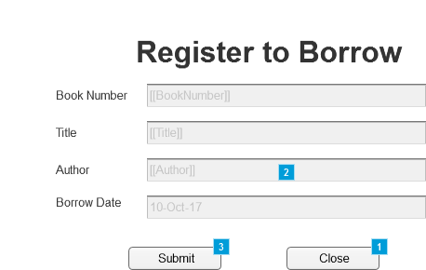

* + 1. Widget Table

|  |  |  |
| --- | --- | --- |
| Footnote | Name | Interactions |
| 1 | button close | OnClick:  Case 1:  Close Current Window |
| 2 | back button | OnClick:  Case 1:  Show (Shape), (Shape), text field title, (Shape), text field author, (Shape), (Shape), text field date, text field book number, button close, button submit  Hide image error, back button, error text |
| 3 | button submit | OnClick:  Case 1  (If text on text field title does not contain "Physics"):  Close Current Window  Case 2  (Else If True):  Show back button, image error, error text  Hide button submit, button close, text field book number, (Shape), text field date, (Shape), text field author, text field title, (Shape), (Shape), (Shape), This |

* 1. Account Settings
     1. User Interface

